(ESP32-Eth-WiFi/LAN8720/OLED/DHT11/Buzzer)
(DuPont Connector)
GPIO | LAN8720 Top | Wire/DuPont | Function
GPIO22 | TX1 (TXD1) | 1 White | RMII Transmit Data 1
GPIO21 | TX_EN | 2 Blue | RMII Transmit Enable
GPIO25 | RX0 (RXD0) | 3 Yellow | RMII Receive Data 0
GPIO17 | nINT/RETCLK | Not connected | CLK_OUT (ignored — LAN8720 has 50 MHz crystal)
GPIO18 | MDIO | 4 Green | MDIO Data
GND | GND | 5 Black | Common ground
3.3V | VCC | 6 Red | Power LAN8720 (do NOT use 5V)
GPIO | LAN8720 Bottom | Wire/DuPont | Function
None | (not connected) | N/C | N/C
GPIO19 | TX0 (TXD0) | 7 Blue | RMII Transmit Data 0
GPIO26 | RX1 (RXD1) | 8 Green | RMII Receive Data 1
GPIO27 | CRS/DV | 9 White | RMII Carrier Sense / Data Valid
GPIO23 | MDC | 10 Yellow | MDIO Clock
GND | (not connected) | N/C | N/C
3.3V | (not connected) | N/C | N/C
GPIO | OLED/LCD2004 | Wire/DuPont | Function
GND | GND | Black | Common ground
3.3V | VCC | Red | Power (do NOT use 5V)
GPIO32 | SCL | 4 Green
GPIO33 | SDA | 7 Blue
GPIO | DHT11 | Wire/DuPont | Function
GND | GND | Black | Common ground
3.3V | VCC | Red | Power (do NOT use 5V)
GPIOXX | OUT | 10 Yellow
GPIO | Relay 5V | Wire/DuPont | Function
GND | DC- | Black | Common ground
5V | DC+ | Red | Power (do NOT use 5V)
GPIOXX | IN | 10 Yellow | NO/COM are used to connect to the door opener
GPIO | Buzzer/Beep | Wire/DuPont | Function
GND | GND | Black | Common ground
3.3V | VCC | Red | Power (do NOT use 5V)
(The following page contains picture of each component.)

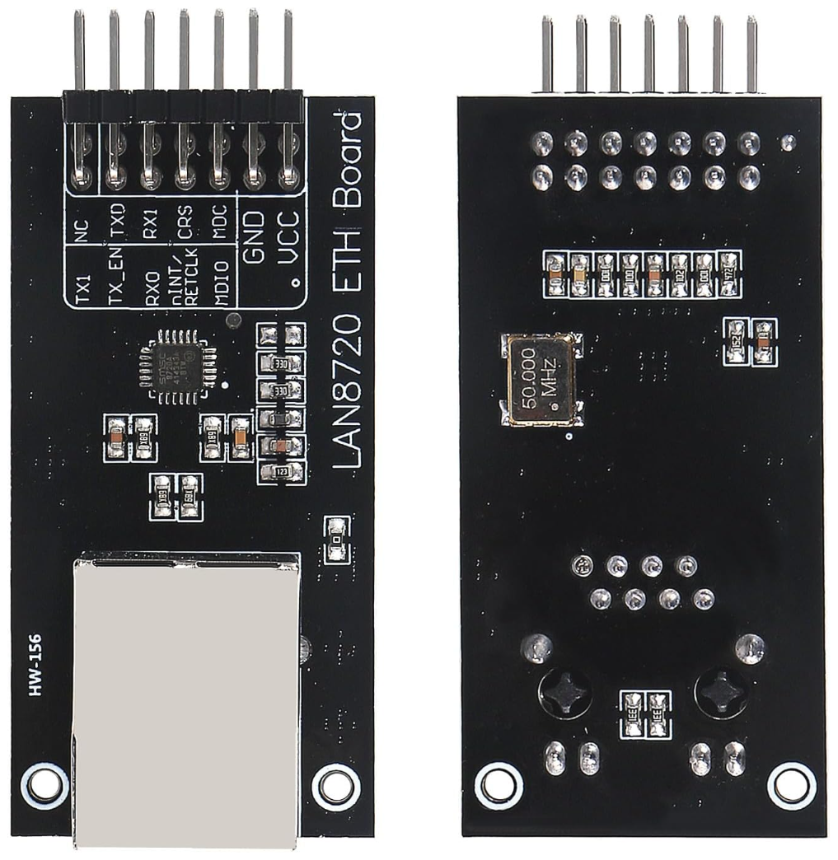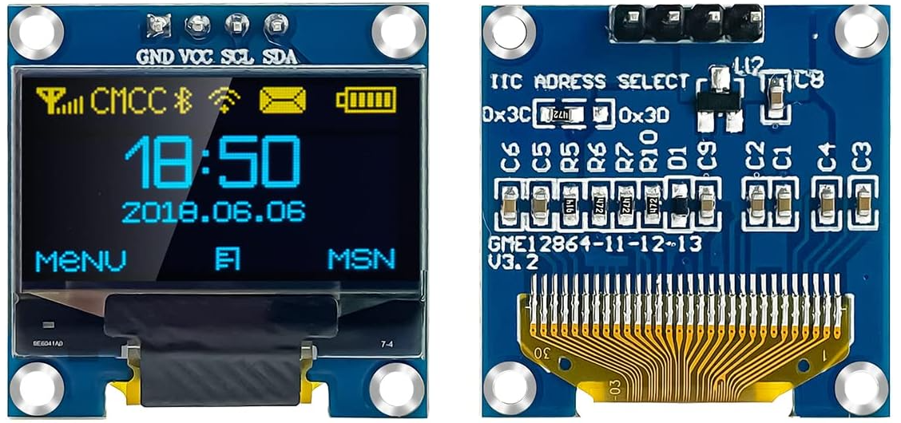
(LAN8720) (OLED)
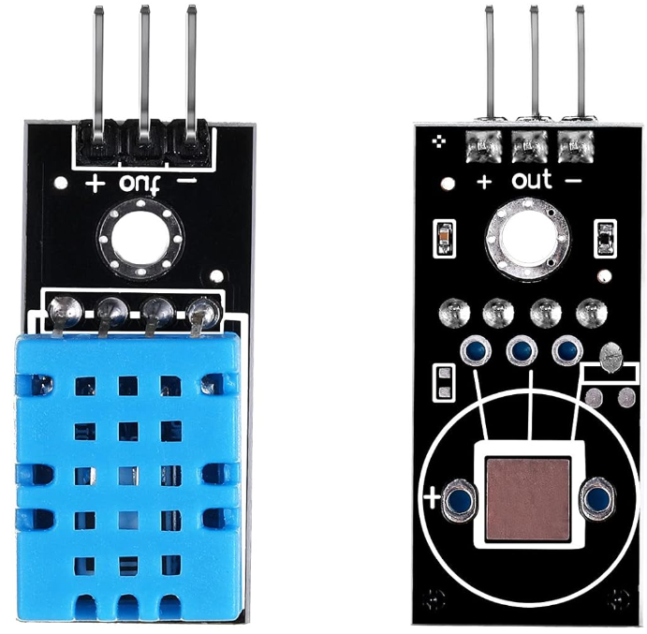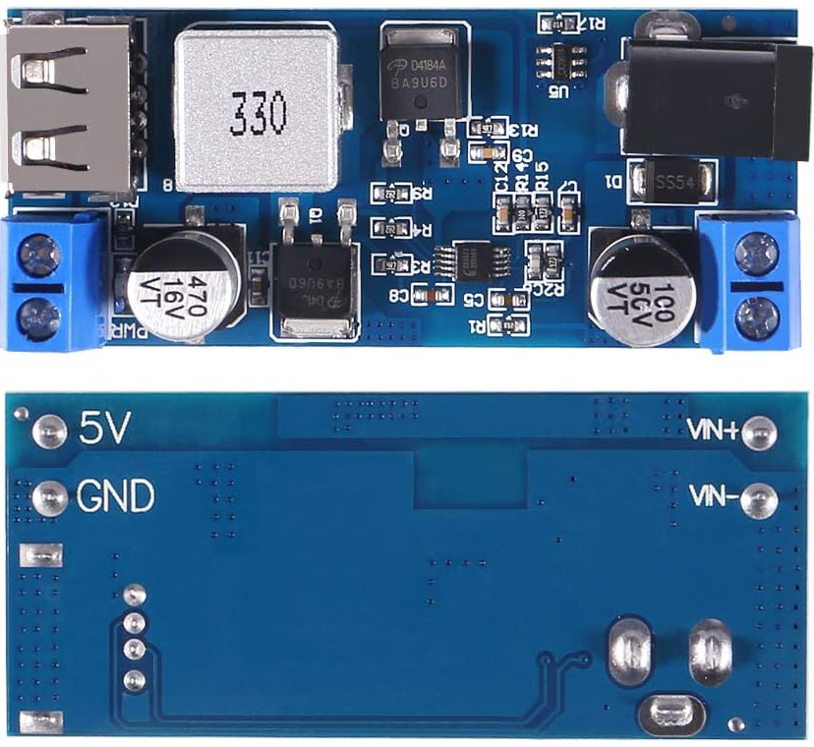
(DHT11) (Buck Converter)
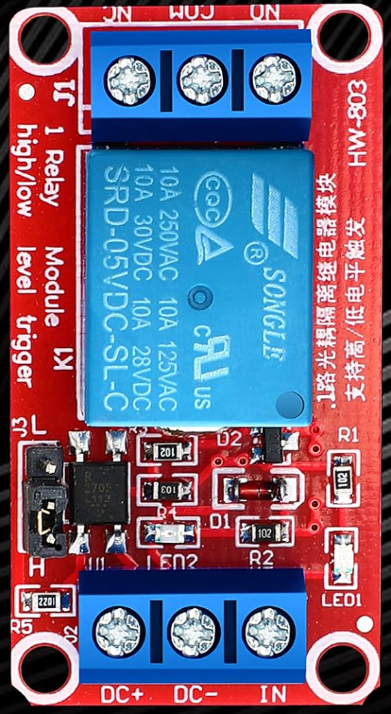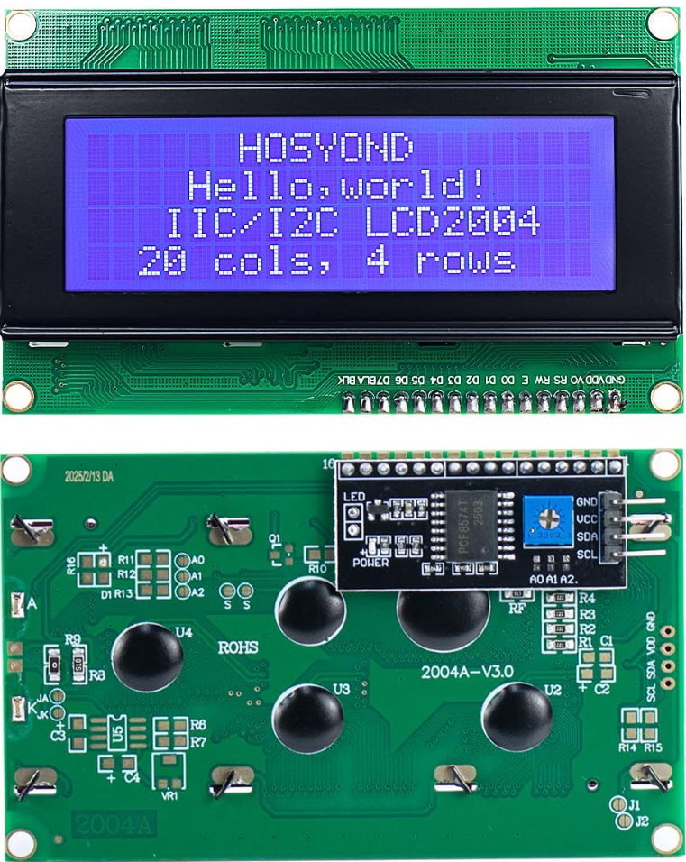
(5V Relay) (LCD2004)
Esp32-C6-Wroom to 38pin Breakout Board:

ESP32-GPIO 38 Pin Header ESP32-GPIO 38 Pin Header
3V3 | 3V3 | GND | GND
RST | EN | TX | P23
4 | SVP | RX | P22
5 | SVN | 15 | TX
6 | P34 | 23 | RX
7 | P35 | 22 | P21
0 | P32 | 21 | GND
1 | P33 | 20 | P19
8 | P25 | 19 | P18
10 | P26 | 18 | P5
11 | P27 | 9 | P17
2 | P14 | GND | P16
8 | P12 | 13 | P4
5V | GND | 12 | PO
GND | P13 | GND | P2
NC | SD3 | NC | P15

GAP-WiFi-c6 Pinout:

Function: GPIO 38 Pin
Garage door relay (to button) | 23 | RX
PIR Inside | 22 | P21
PIR Outside | 21 | GND
Main garage door reed | 20 | P19
Obstruction / safety beam | 19 | P18
I²C SDA (OLED/2004/etc.) | 6 | P34
I²C SCL | 7 | P35
DHT11 data | 2 | P14
Buzzer | 10 | P26
3V3 | 3V3 | 3V3
5V – on 3V3 side | 5V | GND
GND – Refer to above for other GND | GND | P13, P2, P16

GPIO MAP – ESP32-C6 DevKitC-1 (WiFi Panel

GPIO3 -> (free / future)
GPIO4 -> DHT11 Temperature/Humidity (1-wire)
GPIO10 -> Inside garage door reed (INPUT, pullup)
GPIO11 -> Outside garage door reed (INPUT, pullup)
GPIO16 -> Buzzer (OUTPUT, active)
GPIO20 -> Main garage door reed (INPUT, pullup) [Primary door state]
GPIO21 -> PIR Outside (INPUT)
GPIO22 -> PIR Inside (INPUT)
GPIO23 -> Garage door relay (OUTPUT, momentary)
GPIO6 -> I2C SDA (LCD2004 / I2C bus A)
GPIO7 -> I2C SCL (LCD2004 / I2C bus A)
GPIO1 -> (free / future use)

Safe to use on ESP32-C6:
ADC: 0–6, 9 (currently unused)
General-purpose I/O (used here): 3,4,6,7,10,11,16,20,21,22,23

GPIO MAP & AVAILABLE PINS (ESP32-WROOM + LAN8720)

GPIO2 -> DHT11 Temperature/Humidity (1-wire)
GPIO4 -> Garage door relay (OUTPUT, momentary)
GPIO5 -> Buzzer (OUTPUT, active)
GPIO13 -> Inside garage door reed (INPUT, pullup)
GPIO14 -> Main garage door reed (INPUT, pullup) [Primary door state]
GPIO16 -> Outside garage door reed (INPUT, pullup)
GPIO32 -> I2C SDA (OLED)
GPIO33 -> I2C SCL (OLED)
GPIO34 -> PIR Inside (INPUT-only, NO internal pullup)
GPIO35 -> PIR Outside (INPUT-only, NO internal pullup)

Ethernet (LAN8720 - reserved, do not repurpose):
GPIO17 -> RMII CLK_OUT (50 MHz via internal) [WestTech – LAN8720 to ESP32 (Stable-Tested)]
GPIO18 -> MDIO
GPIO23 -> MDC
GPIO19 -> RMII TX0
GPIO22 -> RMII TX1
GPIO21 -> RMII TX_EN
GPIO25 -> RMII RX0
GPIO26 -> RMII RX1
GPIO27 -> RMII CRS

Boot/flash pins to avoid:
GPIO6..11 -> Flash pins (SDIO) — DO NOT USE
GPIO0, GPIO2, GPIO12, GPIO15 -> Boot strap pins; use with care
GPIO1 (TX0), GPIO3 (RX0) -> Serial console; avoid unless you know the trade-offs

Actually available & recommended:
INPUT-ONLY (no internal pullups; use external 10k to 3.3V for NC sensors)
GPIO34, GPIO35, GPIO36(VP), GPIO39(VN)
Typical uses: safety beam, extra door/window reeds, additional PIRs, dry-contact inputs

Usable with care (strap/LED caveats):
GPIO2 -> Strap + often onboard LED on some dev boards; must NOT be pulled low at boot.
Here used for DHT11 (idles high, OK as long as wiring is clean).
GPIO15 -> Strap (usually pulled-down). Safer as OUTPUT; avoid external pull-up at boot.
GPIO0 -> Strap; must be HIGH at boot (LOW enters flash mode) — generally avoid for external buttons.
GPIO12 -> Strap; affects flash voltage; avoid connecting anything that could pull it up at boot.

Wiring assumptions for this version:
- Reeds: 13 (inside), 16 (outside), 14 (main door state)
- PIRs: 34 (inside), 35 (outside)
- OLED: SDA=32, SCL=33, addr 0x3C
- DHT11: GPIO2

